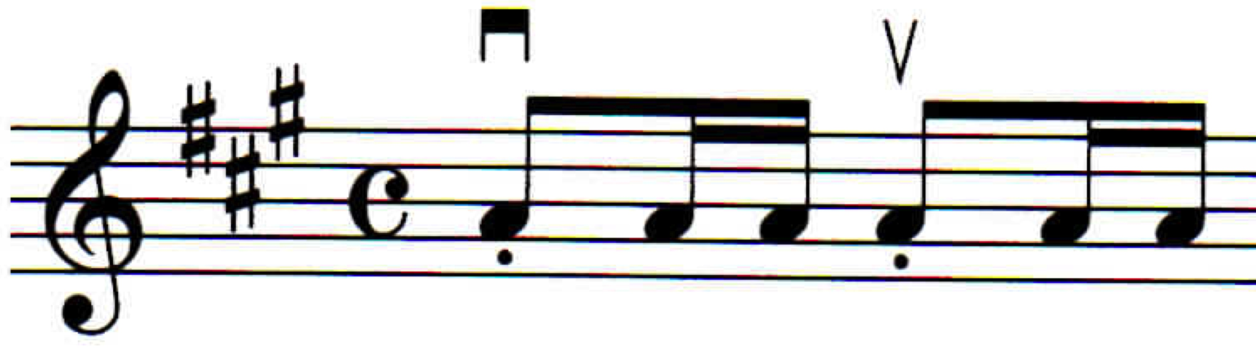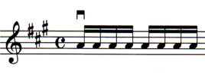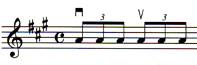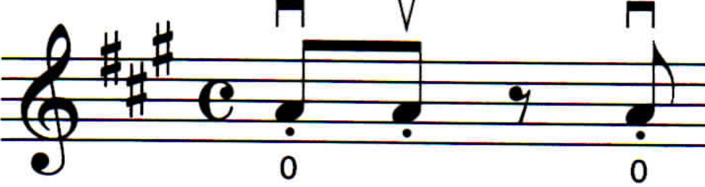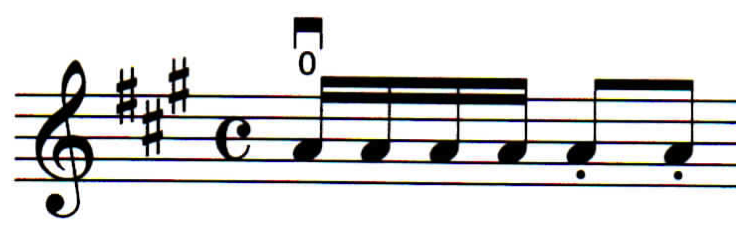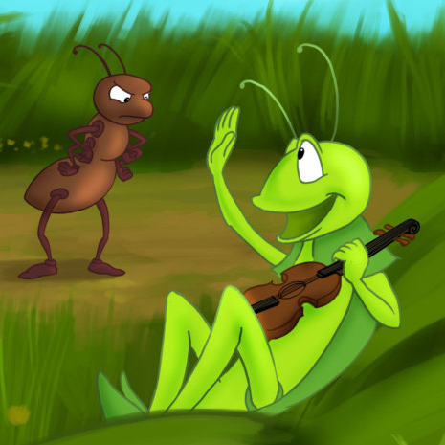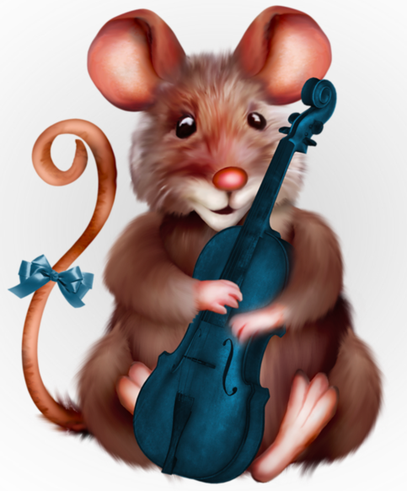

_________________________________________________________________  
*Student of Marissa Keener*

**All You Need to Know  
Pretwinkle Packet**

**TEN KEY SUZUKI ELEMENTS   
in the Suzuki Talent Education Philosophy**  
from an article by Sanford Reuning, adapted by Jessica Spieser-Landes

1. **BEGIN EARLY** Suzuki has found that children can learn very well beginning at the age of 3, and in some cases even earlier. Teaching in the U.S. has substantiated this belief and experimentation is constantly employed to see exactly how young children can begin instruction.
2. **LEARN BY MEMORY** This is the so-called “mother-tongue” approach. All learning in the early years is without printed music. Children learn by small steps, hence memory is developed in a gradual manner until it becomes a high skill. Small children have an almost uncanny ability to work in this manner, the “natural” manner of language learning.
3. **CREATIVE REPETITION** The analogy to language learning is obvious, since the small child is encouraged to say the same simple words over and over until they are mastered. Suzuki limits the amount of material on any given level and encourages much creative repetition.
4. **ACTIVE REPERTOIRE OF ALL PIECES LEARNED** In one’s native tongue, one never gets to the point where a word is learned only to be forgotten. The Suzuki student constantly reviews the repertoire he has learned, and then effectively reinforces his memory, his technical skill, and his musical expression.
5. **LISTENING TO RECORDINGS** As the parent speaks often to his/her child, so the Suzuki student hears recordings of the pieces she is to learn and becomes knowledgeable regarding a fine tone. It is her environment at home which determines so much of her learning.
6. **INVOLVEMENT OF THE PARENT** A parent attends every lesson with the child; encourages him and helps him practice at home each day. The parent becomes the teacher’s assistant responsible for playing the recordings, encouraging the child, teaching the notes (by rote), and practicing with the child.
7. **ENCOURAGEMENT** The parent of a small child doesn’t scold his/her child for mispronouncing words she is learning, but encourages her to say it again and again. Likewise, the Suzuki parent must always encourage the child. The lessons should be a happy experience, and the parent and teacher become involved in the marvel of the unfolding process of learning.
8. **STEP-BY-STEP MASTERY** Each skill is broken down into small segments easily mastered by the student. It is imperative that these segments (and later pieces) be thoroughly mastered before attempting the next step, so as to engineer a “built-in” success for each step in the learning process. This takes skill on the part of the teacher to assess the potential and limitation of learning at a given point in order to effectively challenge the learner.
9. **READING AFTER PHYSICAL CONTROL** If one uses the analogy of native language learning, one speaks before he learns to read. Music reading is also often started as the child begins to read words. By no means, however, should memory learning be dropped when one starts to read notes.
10. **EVERY CHILD CAN LEARN** Eliminate the talent test, and believe that all students can learn to play the violin or any other instrument in the world.

**FIFTEEN KEY SUZUKI ELEMENTS   
for the Home Teacher**  
from an article by Teri Einfeldt, adapted by Jessica Spieser-Landes

1. **DR. SUZUKI ALWAYS SAID “CHARACTER FIRST, ABILITY SECOND.”** The Suzuki experience is about your child first, playing the instrument second. Watch how your child learns, nurturing your child’s spirit and building her self-confidence, yet instilling a sense of achieving excellence at every level.
2. **NO ONE ENJOYS DOING SOMETHING THEY DO NOT DO WELL.** It is normal for the motivation level to shift back and forth between the parent and the child. Focus practices on what the child plays well.
3. **THERE ARE GOING TO BE GOOD PRACTICES AND THERE ARE GOING TO BE BAD PRACTICES.** If your child is not happy about practicing on a given day, it generally has nothing to do with the instrument. My advice is always to try to end the practice before it starts to deteriorate. End on a high note!
4. **PRACTICE MAKES PERMANENT, NOT PERFECT.** Repetitions done incorrectly or without reaching the desired goal your teacher desires are counterproductive.
5. **BE CONSISTENT AND TRY TO PRACTICE ONLY ON THE DAYS YOU EAT.** Each day you skip makes the next time you practice more difficult. Shorter, focused, and consistent practices in which goals are well defined work best.
6. **THE THREE MOST IMPORTANT COMPONENTS OF THIS METHOD ARE PARENT INVOLVEMENT, LISTENING, AND REVIEWING WITH A PURPOSE.** The Suzuki Method is based on the concept of language learning: ear training, repetitions, and cumulative vocabulary words were of the utmost importance when we learned how to speak our first language.
7. **OUR ULTIMATE GOAL IS FOR THE CHILD TO EXPERIENCE INTRINSIC MOTIVATION AS WELL AS EVENTUAL INDEPENDENCE.** Stickers and rewards are extrinsic motivators -- use sparingly.
8. **LEARNING THE NOTES (AND BOWINGS) TO THE NEWEST PIECE IS NOT AS IMPORTANT AS STRENGTHENING THE CHILD’S TECHNICAL FOUNDATION THROUGH REVIEW.** If you learned an instrument as a child via a traditional method, you may have had many books you carried to your lesson that contained etudes. We use review pieces as etudes to reinforce technical and musical concepts.
9. **MUSIC EDUCATION IN GENERAL IS FILLED WITH LIFE LESSONS.** In learning the violin we are identifying a problem or a goal, breaking it down into achievable steps, repeating tasks many times, and celebrating each small accomplishment, a valuable life lesson on how to handle challenges that arise.
10. **CHOOSE A PIECE THREE PIECES BACK FOR PERFORMANCES.** High stress situations for children need to be handled with playing a piece they are confident with playing. It is important to remember the entire world does not know the order of the pieces.
11. **ALLOW YOUR TEACHER TO CONTROL THE LESSON UNLESS YOUR OPINION IS INVITED.** Hearing more than one voice in the lesson is confusing to the child. As the home teacher, your job is to understand the assignment in three ways:
    1. **How it is to be done**
    2. **How many times it is to be done with what outcome**
    3. **The results to look for that match your teacher’s concept of excellence**
12. **COMMUNICATION WITH YOUR TEACHER IS IMPERATIVE.** If you feel uncomfortable or troubled by anything that is happening along your Suzuki journey please take the time to discuss it with your teacher.
13. **NEVER COMPARE YOUR CHILD TO SOMEONE ELSE.** This is one of the least motivating things you can do to your child and has a deep-seated lasting effect.
14. **DO ONLY WHAT THE TEACHER ASKS. DO NOT GO AHEAD.** Teachers are more focused on teaching your child to play her chosen instrument well, than what piece she is playing.
15. **ENJOY EACH STEP OF THE JOURNEY. DO NOT FOCUS ON THE DESTINATION.** Small successes should be celebrated at every turn. All the small steps lead to accomplishment of the larger goal.

# I Love to Practice! by [Joanne Bath](https://suzukiassociation.org/news/author/joanne-bath/)

**“I love to practice!”** That’s what we all want our children to say. Here are some ideas for how parents can get there without resorting to things they wish they hadn’t! These suggestions can keep you motivated so that you can help your children have the best possible musical experience.

**Enjoy the process.** If you can figure out how to have pleasant practice sessions, you and your children will succeed. This may be the hardest part of the whole process, and perhaps the most crucial. Suzuki said that little children should “practice three minutes, five times a day, with joy.” The main goal for practice should be with joy.

**Be consistent.** If your child knows that you will practice every day at the same time, it is easier for you and more secure for your child. Find a time that works best for your family. If you can, practice for ten or fifteen minutes before school.

**Don’t negotiate.** If you practice only when your child feels like it, you will probably never practice. Get in the habit of regular practice and do it. Say, “Practicing is what we do in our family.” I have found that “in our family” is one of the greatest phrases you can use. If children believe that something is done in their family, they will do it!

**Be reasonable—don’t expect perfection.** One of the parent’s most important jobs is to show children that life is not a matter of being perfect, but one of trying new things and growing. We do not want children to be overly cautious about learning. We want them to be interested in a variety of things, and willing to accept a challenge.

**Work for an accomplishment** rather than a set amount of time. One of the best ways you can teach your children to be efficient workers is to stop early when they have accomplished the goals for a practice session. If students can learn to reach their goals in less time, they learn efficiency.

**Do not ask for too much.** If you stop the practice session before the child is ready to stop, the child will want to play again the next day. Suzuki said, “Move slowly and never stop.”

**Gradually lengthen practice time.** Children need to slowly gain physical stamina. They will also have more repertoire as time progresses, and practicing will automatically get longer as they review. Some of my students review a whole book each day.

**Focus on quality rather than quantity.** Small manage-able sections can be worked out with a feeling of success. Do one measure thoroughly so the child can really master it. More is not always better. It is better to play fewer pieces and play them well, so move slowly and carefully.

**Move at your child’s pace.** Compare only so you have a general idea of what others are doing. Allow your child to move at a pace that is natural for her.

**Know what you are doing.** You are the home teacher. To learn what you should be doing at home with your child, ask the teacher. Take notes or tape the lesson.

**Be in charge.** The secret to successful practicing is that the parent must be in charge to a greater or lesser degree depending on the child’s age.

**Focus on what is right.** Tell children what they are doing well. Parents often ask if they can help their children successfully if they are not musicians them-selves. Actually, non-musician parents often have a much easier time than musician parents. Musicians are trained to find mistakes so that they can correct them, while people who are not musicians tend to hear the music and not the mistakes.

**Stay positive.** Be of good cheer. Avoid statements like, “You’re not even trying,” “That’s terrible,” or, “You’re just trying to irritate me!” If you feel something hurtful coming, put your hand over your mouth. Do not say something that could destroy weeks of positive growth.

**Remember the power of praise.** Praise always accomplishes more than criticism. Sometimes it is not just praise but acknowledgment. Acknowledge what the child is doing. Keep a running list of all the wonderful things that your child does. If your child is just starting to read, make the list in large print so the child can read for himself all the things that he did well.

**Give rewards.** From the beginning, try to establish the desire and pattern of practice. You don’t have to always give rewards, but if you do at certain times, you’ll find that you will get good work from your child. Austin, our six-year-old grandson, will work hard for shiny pennies, which we call “gold coins.” I sometimes give him one for everything he does well in a practice session.

**Consider listening part of practicing.** Listening makes the practicing and learning easy. Put your child to bed every night with a tape of the next piece. He will be able to learn the notes to that piece very rapidly, and all you will have to do is show him the bowings. If you are in a time crunch, and simply can’t practice one day, listen. If you have to choose between practicing and listening, listen. If you go on a camping trip and you can’t take the violin, take the tape player and listen.

**Give projects and assignments.** Deadlines and performances are very motivational. A performance could be just making a video or audio tape for the grandparents, or playing over the telephone. Get children to play as much as they possibly can.

**Review every day.** Most of my students have a review chart. When they are more advanced, they may do three pieces from each book or they may do one book a day. The students at the end of Book 2 should play all of the pieces in Book 2 every day. This may mean two practice sessions. If your child is in Book 1, he should be practicing all of the pieces in Book 1 every day. **Play review games.**

**Divide practice sessions in approximate thirds:** one-third review, one-third preview, and one-third polishing. Polishing means working on the last three pieces and getting those performance ready.

**Help older children find time to practice.** One of the best things you can do is to excuse your teenager from some household tasks in exchange for practicing. Make it easy for them.

This is a very special time that you have with your children. You have your child one-on-one during practice. Sometimes that is the only time that a parent and child have alone together. Treasure your children and their accomplishments. Be understanding, encouraging and loving and I promise you that you will have success beyond anything you could have ever imagined!

**Variation A**

Mississippi hot dog

**Variation B**

Ice cream, shh! cone

**Variation C**

Down Pony Up Pony

**Variation D**

Pineapple pineapple

Strawberry blueberry

**Variation E**

Michael Michael motorcycle

**Rocket Song**

Up like a rocket, down like the rain.

Back and forth like a choo-choo train.

‘round and ‘round like the golden sun,

Bow in your hand, curved pinky, bent thumb.

Up like a rocket, down like the rain.

Back and forth like a choo-choo train.

*Other fun songs to do with a great bow hold are The Grand Old Duke of York and the Wheels on the Bus.*

**The Monkey Song**

I’m a little monkey

Climbing up a palm tree

Climbing way up high to

Pick a green banana!

I’m a little monkey

Climbing down a palm tree

Climbing to the ground to

Eat my green banana

**Eek Eek Eek!**

Eek eek eek!

All the little

Ants, ants, ants.

They are going

Down down down

Way down to the

Ground ground ground!

**Rest Position Song**

Rest position – feet in line,

Scroll in front, it’s mighty fine.

Check your bridge ‘cause it should be,

Peeking out at you and me.

Now it’s time to take a bow:

One and two and three is how!